bc  

**MEMO Number**: CMPE320-S21-004

**DATE:** 05/02/2021

**TO:** EFC LaBerge and CMPE 320 Peers

**FROM:** Nem Negash

**SUBJECT:** Project 4: MAP and ML Detection of Binary Signals

# introduction

The purpose of this project is to simulate the common problem in transmission of digital information, the variation of the bit error rate (or probability of bit error) as a function of changing the signal-to-noise ratio at the detector input. For this project we will be using a MAP detector and a ML detector to simulate and estimate the percentage of errors in a given stream of data.

# Simulation and Discussion

## Design the MAP detector

*Conditional PDF of M*

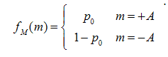

*Conditional PDF -> Joint PDF*

$$f_{R,M}\left(r,A\right)= f_{R|Ho}\left(r | H1\right)*Pr\left[H0\right]= f_{R|Ho}\left(r | H0\right)*(p0)$$

$$f_{R,M}\left(r,A\right)= f_{R|Ho}\left(r | H1\right)*Pr\left[H1\right]= f_{R|Ho}\left(r | H1\right)*(1-p0)$$

*Likelihood Ratio*

$$L=\frac{f_{R|H0}\left(r | H0\right)}{f_{R|H1}\left(r | H1\right)} = \frac{\frac{f_{R,H0}\left(r | H0\right)}{f_{R}(r)}}{\frac{f_{R,H1}\left(r | H1\right)}{f_{R}(r)}}=\frac{f_{R,H0}\left(r | H0\right)}{f_{R,H1}\left(r | H1\right)}= \frac{f_{R,H0}\left(r | H0\right)*Pr[H0]}{f_{R,H1}\left(r | H1\right)*Pr[H1]}$$

$$L = \frac{\frac{p0}{\sqrt{2πσ^{2}}}*e^{{-{\left(r-A\right)}^{2}}/{2σ^{2}}}}{\frac{1-p0}{\sqrt{2πσ^{2}}}*e^{{-{\left(r+A\right)}^{2}}/{2σ^{2}}}}= \frac{p0}{1-p0}*e^{\frac{-{\left(r-A\right)}^{2}}{2}}= \frac{p0}{1-p0}*e^{\frac{2rA}{σ^{2}}}$$

*solve for ‘r’ to find $τ_{map}$*

$\frac{p0}{1-p0}*e^{\frac{2rA}{σ^{2}}}$ = 0**,** *r =τ*

$$\frac{p0}{1-p0}*e^{\frac{2τA}{σ^{2}}}=0→\ln{\frac{p0}{1-p0}*e^{\frac{2τA}{σ^{2}}}} =0→\log{(}\frac{p0}{1-p0})+\frac{2τA}{σ^{2}}= 0$$

$$τ_{map}= \frac{\log{(\frac{1-p0}{p0})}*σ^{2}}{2A}$$

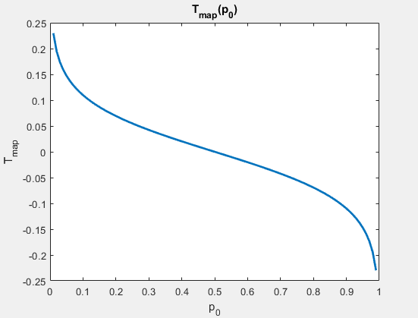

Figure :Tmap as a function of P0

The derivation of the $τ_{map}$ function is shown above the plot. **Figure 1** shows $τ_{map}$ as a function of P0 which shows it is a logarithmic function. The plot also shows that as P0 gets closer to 0.5, $τ_{map}$ gets closer to 0. This is because as the two probabilities get closer to 0.5 there is no threshold gain for either the positive or negative signals. As the log of the value becomes more positive, which is means the ratio is above 0, $τ_{map}$ also becomes positive. This leads to more received values being mapped to a negative value by the detector, since the chance of negative value will be higher of $τ_{map}$ is well above 0. Similarly, if the ratio value is less than 0, then the log value will also be negative which leads to more values being mapped to a positive value.

## Investigate the MAP detector

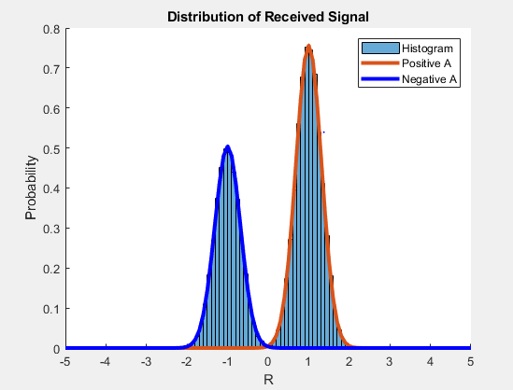

Figure : Distribution of Received Signal

**Figure 2** shows the bimodal distribution of the received signals. The point at which the two curves interest in the plot is where $τ_{map}$ lays. The two mounds in the graph represent the received signals where the left is the negative signals, and the right is the positive signals. The left hump, which represents the negative signals, is lower than the right since P0 = 0.6 which maps to positive values which makes the positive portion higher.

## Evaluate the ML Detector

### Find the ML threshold

$$τ_{map}=\frac{\log_{10}{\frac{1-p0}{p0}*σ^{2}} }{2*A}$$

$$τ_{map}= \frac{\log{\frac{0.5}{0.5 }*σ^{2}}}{2A}=0$$

$$τ_{map}=0$$

In this section, P0 = 0.5, which means the log ratio evaluates to equal 0. Since the ratio is zero, $τ_{map}$ is also equal to zero. The $τ_{map}$ value is used to determine if the received signal is going to be mapped either as a negative or positive value. The $τ_{map}$ being zero means that the simulation does not favor mapping the received signals to either a negative or a positive value.

### Derive the probability of error

$$P\left(error\right)=fB\left(b\right)=\left\{\begin{aligned}p0, b=0 \\ 1-p0, &b=1\end{aligned}\right.$$

*For p0, b = 0*

$\int_{τ}^{∞}{f_{b}+P\left(0\right) dr}$

$$\int_{τ}^{∞}{\frac{0.5}{\sqrt{2πσ^{2 }}}e((A-τ})/2σ^{2}dτ$$

$0.5*Q\left(\frac{A-τ}{σ}\right)$

$0.25*erfc(\frac{1}{\sqrt{2*σ^{2 }}}$)

*For 1-p0, b = 1*

$\int_{-∞}^{τ}{f_{b}+P\left(1\right)dr}$

$\int_{-∞}^{τ}{\frac{0.5}{\sqrt{2πσ^{2 }}}e((A+τ})/2σ^{2}dτ$

$0.5*Q\left(\frac{A+τ}{σ}\right)$

$0.25*erfc(\frac{1}{\sqrt{2*σ^{2 }}}$)

$$P\left(error\right)=p_{0}+(1-p_{0}) = 0.5 * erfc(\frac{1}{\sqrt{2*σ^{2 }}})$$

### Simulate the ML detector.

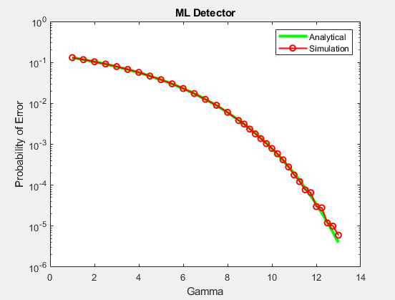

Figure : ML Detector

**Figure 3** compares the analytical function that was derived to the simulation plot and how they match up well. The plot shows that as gamma increases the Probability of Error decreases. This is because as gamma increases the variance of the noise decreases. This leads to more received signals that are more focused around the mean, which leads to a lower chance that the received signal is mapped to the wrong value.

# 2.4 Evaluate the MAP Detector

# 2.4.1 Derive the probability of error using the MAP threshold

$$P\left(error\right)=\left(b\right)=f_{B}(b)=\left\{\begin{aligned}p0, b=0 \\ 1-p0, b=1\end{aligned}\right.$$

$τ_{map}= -10db\log_{10}{σ}$

*For 1-p0, b=1*

$\int_{-∞}^{τ}{f_{b}+P\left(1\right)dr}$

$\int_{τ}^{∞}{\frac{0.4}{\sqrt{2πσ^{2 }}}e((A+τ_{map}})/2σ^{2}dτ$

$0.5*Q\left(\frac{A+τ_{map}}{σ}\right)$

$0.2*erfc(\frac{A+τ_{map}}{\sqrt{2*σ^{2 }}}$)

*For p0, b = 0*

$\int_{τ}^{∞}{f_{b}+P\left(0\right)dr}$

$\int_{τ}^{∞}{\frac{0.5}{\sqrt{2πσ^{2 }}}e((A-τ_{map}})/2σ^{2}dτ$

$0.5*Q\left(\frac{A-τ_{map}}{σ}\right)$

$0.3*erfc(\frac{A-τ_{map}}{\sqrt{2*σ^{2 }}}$)

P(error) = $=p_{0}+(1-p_{0}) =0.3*erfc(\frac{A-τ_{map}}{\sqrt{2*σ^{2 }}}$) + $0.2*erfc(\frac{A+τ_{map}}{\sqrt{2*σ^{2 }}}$)

The derivation of P(error) is similar to section 2.3 except that P0 = 0.6. This changed the P(error) for this section since the change in the value of P0 led to the threshold ($τ_{map}$) no longer being zero. This results in having two terms for the P(error) function.

# 2.4.2 Simulate the MAP detector

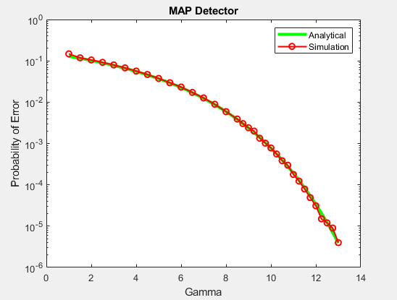

Figure : MAP Detector

**Figure 4** shows the probability error with the MAP detector. For the MAP detector the $τ_{map}$ value changes with each variance. The analytical function and the simulation plot match up well. Similarly, to **Figure 3** the probability of error decreases as gamma increases. A gamma value of about 13 leads to the least amount of bit errors.

## Compare the MAP and ML Detector performance

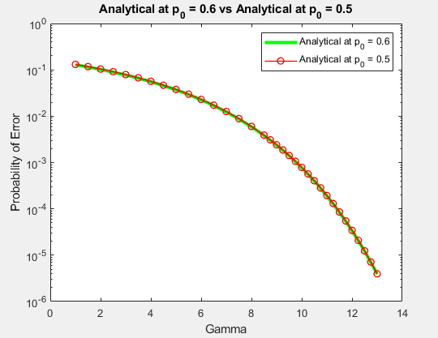

Figure : Comparing Analytical functions for P0 = 0.6 and P0 = 0.5

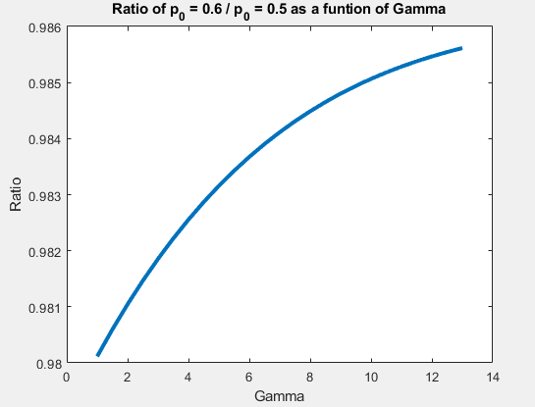

Figure : Ratio of Analytical functions P0 = 0.6/ P0 = 0.5

**Figure 5** shows the analytical function from section 2.3 compared to the analytical function from section 2.4. The two function are almost identical which means the two detectors would perform very similarly. **Figure 6** shows the ratio of the two analytical functions for each detector. The plot shows that as gamma increases the ratio of the two functions also increase. Since the ratio is really close to one, the difference in the performance of two detectors is minimal if any even though the MAP detector is more accurate since the ratio value is less than one.

# What I learned

This project has really given me a much better understanding of error checking occurs in data transmission. It’s interesting to see how accurate the detectors are and how there is a limit to how accurate bit error checking is. This project has also expanded my understanding of MATLAB functions by using functions such as semiology and the different types of files MATLAB provides such as scripts and live scripts.

## Future suggestions

This project overall was good. It was concise, instructive, helped me learn a lot about MATLAB, and strengthen my understandings of the topics covered in lecture.

## Time spent

|  |  |
| --- | --- |
| Topic | Time Spent |
| Reading | 5 hours |
| Research | 10 hours |
| Programming | 10 hours |
| Writing | 10 hours |
| Final Preparation | 5 hours |
| **Total:** | 40 hours |